Module 1

Assignment 1.2
Course: CSD402-340A Java for Programmers
Prepared By: Mirach Erkol
Date of Report: 1/18/2025

https://github.com/Mikey5007/CSD340.git

1.2 Assignment: Local Directory Setup
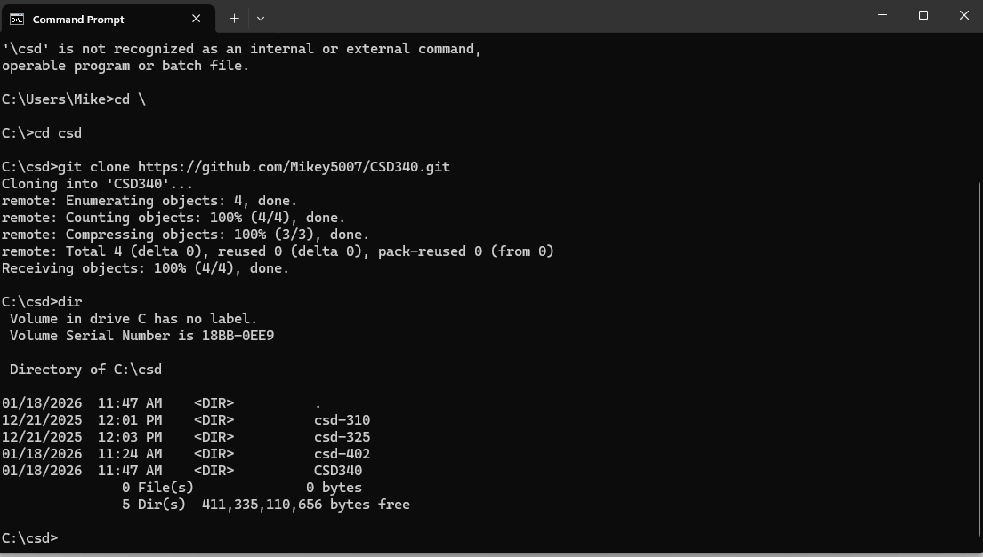1.2 Assignment: Local Directory Setup Modified README.md
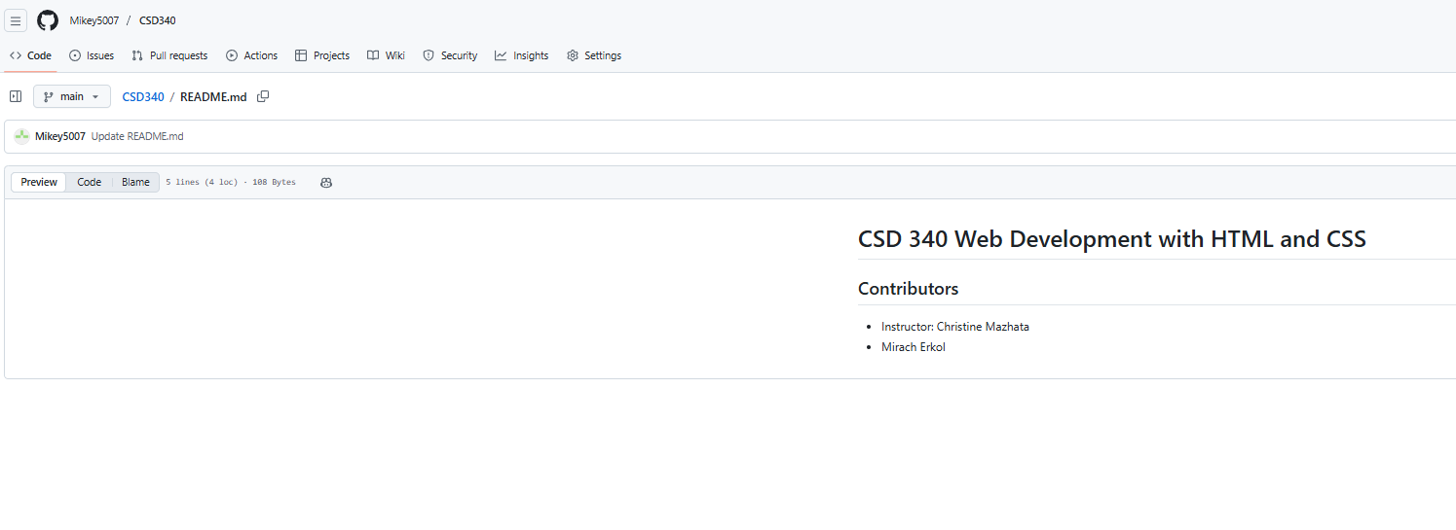

1.2 Assignment: Repository Structure
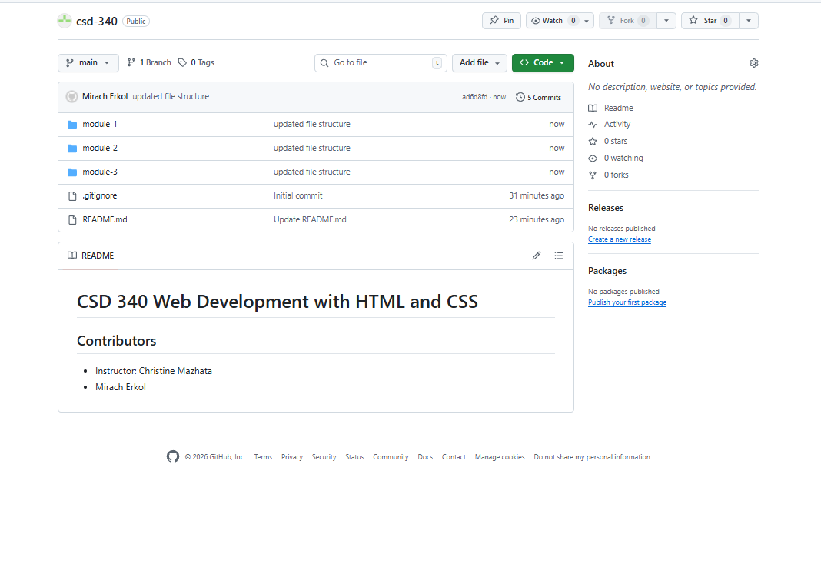
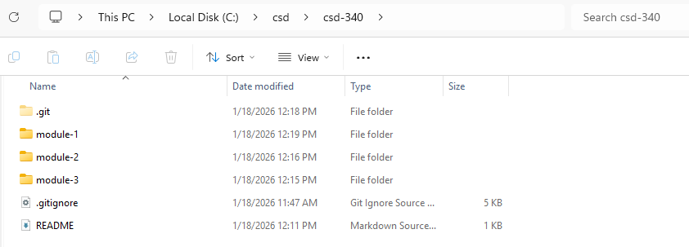

References:

https://github.com/Mikey5007/CSD340.git

